BUSA 465- Technological Entrepreneurship

Final Project

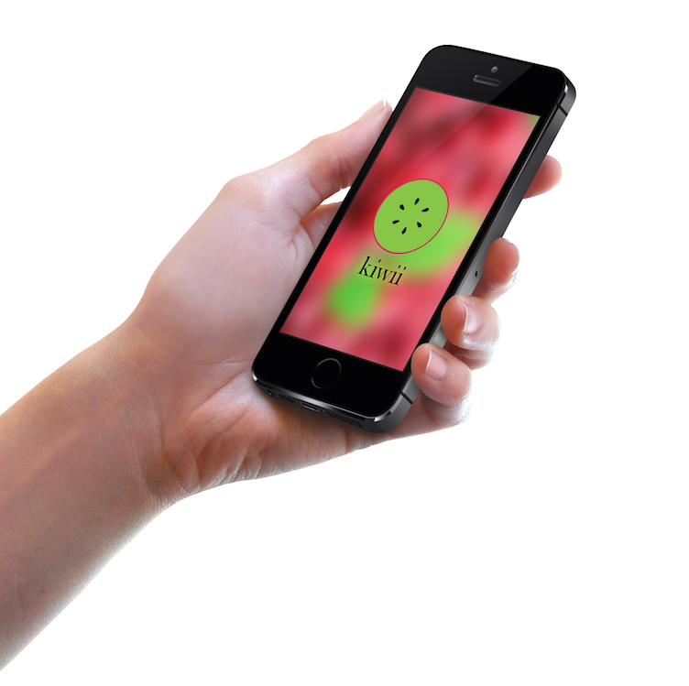  
  
Kiwii - *Smartphone Application*

**Group D**

Ashleigh Collins 260453747

Pierre Farah 260462878

Harrison Goldstein 260476238

Fred Lacasse 260481740

Muhammad Ammar Raufi 260504960

Through the creative process, we identified an opportunity in providing a technological service, with purpose to increase the ease and efficiency of users’ grocery shopping experience. To this end, we have developed a smartphone application for students and young adults (millennials aged 18 to 35) in Montreal, people who are looking for a more efficient way of organizing and planning their grocery shopping experience. Our product - The Kiwii App is a smartphone application that provides assistance to shoppers through the shopping process. Kiwii assists these users from the planning stages of users’ shopping trips, right through to the billing of their carts. Unlike traditional methods, the app is a comprehensive shopping assistant.

The Kiwii App; description and features are addressed in the following section. All features can be accessed from a sliding menu *(Exhibit 1)* mechanism at anytime during use (*for full set and description of features, please see Exhibits*).

**Creating a New List (See Exhibit 2 for a more detailed explanation)**

The main feature of the app is to aid the process of planning a shopping trip. To do so, the user is guided through the creation of a list, selecting products from the Kiwii Database’s suggestions.  These suggestions are based on user preferences. The app then generates estimated prices for each grocery store and give instructions to reach each one of them.

**Shopping Mode (See Exhibit 3 for a more detailed explanation)**

In “Shopping Mode”, the user can decide to split their list with other users (from Facebook, Twitter, or address book). This option offers different splitting modes to calculate the end bill (100%-0%, 50%-50%, custom), and enables users to tag some products as “personal adds”.

There are a few other players in the grocery store app market such as ‘Grocery gadget’ and ‘Grocery IQ’. These two apps offer few and limited features such as listing capabilities and store locations. Neither of these competitors offer the features that we will provide through Kiwii.

Kiwii’s **differentiated positioning strategy** is to offer the service at no charge. To compensate for this, we will later address our pricing strategy on how we will recover our sunk costs, and eventually turn a profit.

**Opportunity and the value proposition**

*Target Market Opportunity*

The smartphone applications sector has been rapidly increasing over the past few years. A report on “The Canadian Press” claims that there are 2,141,564 smartphone users in Montreal, with an average of 30 apps installed on there phone, demonstrating that more and more people are relying on apps to facilitate their daily activities (The Canadian Press, 2013). Our target market is students with busy lives who have a need to limit their time spent shopping for groceries. Montreal is an ideal place to launch this app, especially because it is home to large universities, such as McGill and Concordia.  A survey carried out by us in Montreal shows that 51% of the students here do grocery at least once every two weeks. We, as students,  understand the tiresome task of “doing groceries”, and therefore believe that there is a large demand for the service we provide.

*Purpose of Service*

As previously mentioned, shopping for groceries is tiresome. Students are faced with the task of selecting a store, finding products in that store, fighting to split the bill evenly, and finally getting home, only to realize you forgot to buy something. Kiwii provides a smart, easy, and efficient way of organizing your shopping trip from the planning, to the bill, and everything in between.

**Product Roadmap**

Through the use of the Lean Startup Process, we have established that our vision is *to provide an application/service to help increase the ease and efficiency of the grocery shopping experience for the the everyday, busy individual*.

*Value Hypothesis & Growth Hypotheses*

We plan to test the validity of the assumptions/hypotheses of the key aspects of our business strategy with focus of the 2 types of hypotheses’ that need testing. In terms of our Value Hypothesis, we aim to test whether the features Kiwii offers delivers value to users once they are using the app. Based on the Lean Startup, experiments provide learning rather than surveys, which simply ask for the user’s opinion. Instead, we intend to test our new features on the app, and ask users to rate it after their first, fifth, and tenth use.  With regard to our Growth Hypothesis, we understand that the focus needs to be on *how* new customers will discover the app. This will be done through the process of users sharing the use of Kiwii via social media platforms, and word-of-mouth. Our ultimate goal would be to reach a stage of viral use of our application, with repeated use from existing users, in order to ensure that the frequency people use Kiwii.

We have defined a set of analogsin relation to the creation of Kiwii. First, Kiwii users are aware of their price and quality preferences in terms of products. Second, these users will be willing to make concessions, in terms of loyalty and price of products, in order to save money or gain in quality of products they purchase.  Finally, these users want to plan their shopping trip (take time to write a list).

We have also established a set of anti-logs in relation to Kiwii’s creation. Grocery stores will be willing to share continuous product information with us, in order for us to build a database for our app and food companies will be willing to pay to have priority in our food database.

*Minimum Viable Product (MVP)*

The lite version of the Kiwii app will act as our Minimal Viable Product (MVP), which will be the first version that will undergo the full “build-measure-learn” feedback loop. We will focus on attracting the early adopters of Kiwii, who will provide us with valuable feedback.

*Innovation Accounting*

We plan to measure the metrics that will yield valid and useful information for us to measure Kiwii’s progress. Our first step will be to use our MVP as a baseline and track progress from that standpoint. We will accumulate data from the first learning milestone and evaluate the conversion, sign up, and trial rates. We will identify, from the smartphone users who sign up and download Kiwii, how many convert to *actual* users, and further, how many become paying customers (paid for premium version and potential add-ons). From here, we will gather information through the feedback provided from the users and test their reactions to the user interface (UI), as well as to the user experience (UX).

Our next step is to tune the engine from the baseline to the idea. Our design experiments must clearly measure which design changes lead to positive results, as it may take several iterations in the BML feedback loop.

The third, and final, step is to determine whether to pivot or persevere. If our startup is making positive progress towards our defined ideal, then we will persevere. Otherwise, we will pivot. The fact that our product is a mobile application enables us to pivot, persevere, or make small changes quicker than if it were a tangible product.

*Learning Milestones*

Learning milestones will helps us identify what works versus what does not. Some vanity metrics can be useful, such as number of downloads; however, we are focused more on the actionable metrics that relate directly to the principles of cause and effect. Further, we want accessible metrics that are simple and easy to understand. Finally, we want auditable metrics that ensure data is credible.

Some of the metrics that we will be measuring include: the percentage of active Kiwii users - those who downloaded it and actually used one of its features, the usage rate - which tells us if the user was satisfied by the user experience, the viral coefficient, and the time each user spends using the app.

Because the users are able to sign up via Facebook or Twitter (particularly in the case of list splitting), Kiwii will have access to the basic information of each of its users, such as age and sex. It will then be easy to relate the shopping behavior of these users to this information, thus generating patterns and detecting trends among specific social groups.

Split test is an alternative tool to test what works better. Through this method of gathering and analyzing information, we will achieve validated learning.  We will be able to understand clearly which elements of the strategies used are working and what our users *really* want. We could test the consequences of offering a Freemium plan (Free and Premium versions) alongside a Free Trial plan (offer features for free for a predetermined number of days before charging the user). Split test could also be used when trying a new feature, adding a new section, or modifying an existing one, and could be used amongst different cohorts.

*Pivot or Persevere: Decision*

Throughout the startup stages of launching our app we will focus on consistently and quickly reacting to our customers’ feedback to ensure continuous optimization, and thus customer satisfaction. It is crucial to be able to bring users to download and begin using the app, but the real challenge lies in retention of the existing users. This is the reason why the data measured through the BML loop must always be taken into consideration.

Also, at different stages, and always according to data analysis, we will need to decide whether to pivot or persevere our strategy and fix new objectives. Out of the many forms of existing pivots, we believe that three are the most relevant.

First, we could potentially implement a “zoom out” pivot. In fact, the whole grocery shopping planning experience could become a single feature of a larger app or platform, including other kind of shopping.

Second, we might use a “technology pivot”, thus integrating new technology into the app. The new potential technologies could be related to the development of the “Internet of Things” and the connectivity ability of more appliances to the app itself.

From the Lean Startup’s ways to drive sustainable growth, we have identified three modes that would be useful. The first is word-of-mouth, which relies on customer satisfaction. The satisfied users will introduce their friends and family to Kiwii, and some of them will rate it through online forums and specialized websites. The second is driving growth as a side effect of product usage. This is achieved through the “bill splitting” feature which leads the user to invite a friend to download and use Kiwii. The third is through advertising. In this case, we would use the grocery chains with whom we will be partnering to suggest the use of our app in exchange of featuring their stores.

The viral and the sticky engines of growth are most relevant to Kiwii. These two engines of growth are what we ultimately wish to attain; the viral engine will serve us in attracting new customers while the sticky engine will retain these users and encourage them to use our product.

**Marketing Plan**

*The Big Opportunity*

Shopping can be extremely daunting and time consuming for many individuals.  Between work, school work, and other responsibilities, it is difficult to find time to devote solely to shopping.  Kiwii aims to take the pain out of shopping for groceries and instead create a more enjoyable, less time consuming, and more efficient shopping experience. Kiwii falls under the “expanded category” and proposes a new solution to a broader problem, by providing users with a more efficient way of organizing their grocery shopping experience with regard to (1) ease of creating, storing, and organizing their shopping list,  (2) splitting grocery bills among “group shoppers”, (3) identifying the cheapest options for products, and (4) locating a store nearest you.  In a nutshell, Kiwii envisions a faster, better, and cheaper shopping experience for each of its users. We believe there is a great opportunity to seize, since there is a need for this kind of comprehensive service and since the potential customer base is important.

*A Defendable Differentiated Position*

We have identified a need to develop features that create and add value for the Kiwii users. Some of these key features include: ease of use, history of previous lists and suggested lists, product recommendations, advertising of product specials, product preference options, ability to choose and adjust products choices (and ultimately store location choices) according to personal price/quality preference, ability to compare between different stores based on these product choices, bill-splitting option, and product barcode scanning ability.

*Winning Go To Market Plan*

The grocery store market is vast and vague. In order to appropriately market Kiwii, we must target several specific target markets: Students, Housewives, and other individuals (smartphone users) who do the majority of grocery shopping for their household.  Within these specific target markets, we will begin by marketing our app towards millennials by creating an online presence for Kiwii. Kiwii will be accessible through its webpage as well as on Facebook. Kiwii will also offer tech support via email where users are encouraged to submit any feedback, ideas, or concerns pertaining to the functionality of the app.

*Sustainable Value*

We want to encourage users to try Kiwii, therefore the basic version will be offered for free in the App Store. In order to entice users to use and invite their friends to Kiwii, we plan on forming relationships with grocery stores where they will provide a 5% rebate per visit for each new user the current user attracts.  Consequently, these grocery stores’ products will appear at the top of our suggestion lists more frequently. We plan on generating income through advertisements of product as well as through recommended items catering towards specific individuals.

There will be the option for users to upgrade to a Premium version of Kiwii that offers the option to make longer lists, to compare between more grocery stores in a wider range. The price of this upgrade will be a one-time fee of 0.99 CAD. Based on the results from our survey (Exhibit 7), we believe it is a reasonable price that users will be willing to pay.

Our next step is to focus on add-ons. Add-ons, extensions of the app, applications to Internet of Things, sustainable interest in the excitement of the integration of all of these technologies in order to provide easier, more efficient and more exciting experiences surrounding activities, such as that of grocery shopping.

The scanning feature of Kiwii is the first example of an innovative, simple, user-friendly feature that supports the Internet of Things (IOT) trend. Integration with the IOT allows for many possibilities of minimizing customer pain that may arise with the shopping experience in the future. We will learn about these pains as the market evolves in the future. Cisco is evaluating this IOT to be a $14.4 trillion market by 2023 (Rossi, 2014). Kiwii has huge potential to be a pioneer in this revolution. There are already “Smart Fridges” selling in the marketplace and these kind of appliances will take over regular appliances. Our product is designed to be ready to partner with companies similar to the one producing the “SmartFridge”, by having the ability of being connected with such appliances. Therefore, a grocery list could be automatically created without the user having to type, or scan each individual product that they are looking to purchase.

Citations:

The Canadian Press. "Smartphone Use Way up in Canada, Google Finds." *CBCnews*. CBC/Radio Canada, 29 July 2013. Web. 24 Mar. 2014.

Rossi, Ben. "Next Big Thing: Preparing for the Internet of Things in the Enterprise."*Information Age*. N.p., 7 Mar. 2014. Web. 24 Mar. 2014.

**Exhibit 1: “Sliding Menu”**

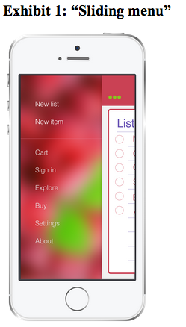

**Exhibit 2: “New List”**

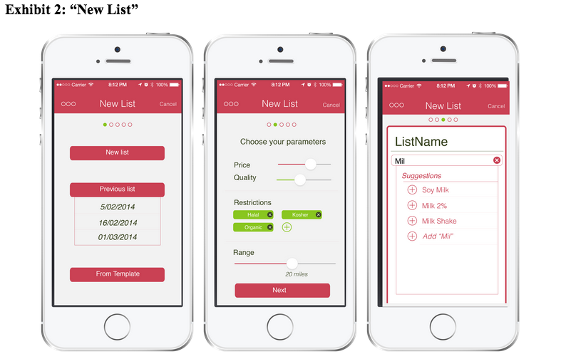

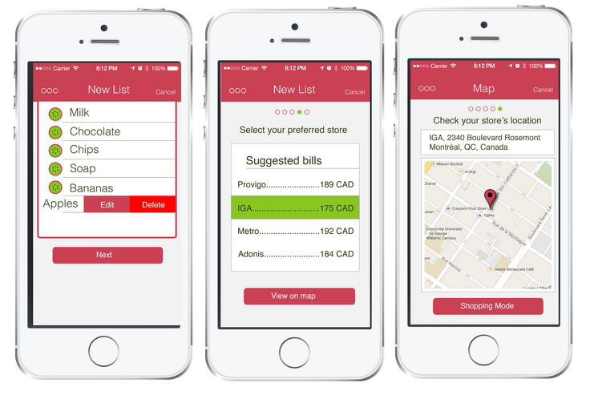

The main feature of the app is the process of planning a shopping trip. The user has the option to either choose between previous lists or templates, or to create a new shopping list. In this case, the user must specify his preferences regarding the importance of price and quality of the items he chooses, the restrictions relative to his diet (vegetarian, organic, kosher, halal, and others), and the distance in which grocery stores should be located. The user then proceeds to choose his products by selecting items from Kiwii’s database. This data will be collected from partnerships with relevant grocery stores, such as Provigo and IGA. The app finally calculates a precise estimate of the cart’s price for each different store in the chosen range. When the user chooses his preferred store, the app conveys all the necessary information to reach it (maps, directions, and address).

**Exhibit 3: “Shopping Mode”**

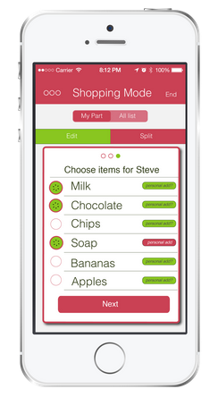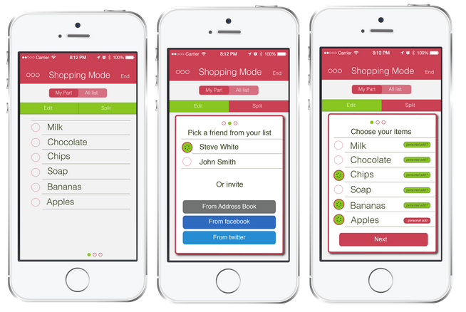

While shopping, the user enters the app’s “Shopping Mode”. In this mode, he has the option of sharing the shopping list with other users. These users can be selected via Facebook and Twitter, or directly from the app’s user directory. Upon being asked his ideal way of splitting the end bill (100%-0%, 50%-50%, custom), the user could select items as being “personal adds” to one of the individuals. Even though the payment is not made through the app, each user is notified of the amount he must contribute

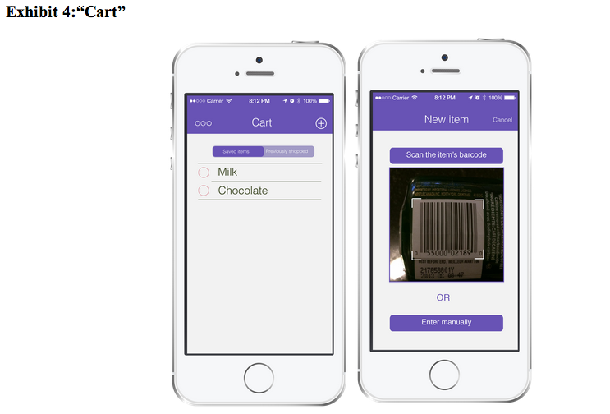**Exhibit 4: “Cart”**

The cart contains the list of “saved items” and “previously shopped items”. Previously shopped items are automatically added to this section after a shopping trip has been made. Saved items are added either manually or by scanning a product’s barcode.

**Exhibit 5: “Explore”**

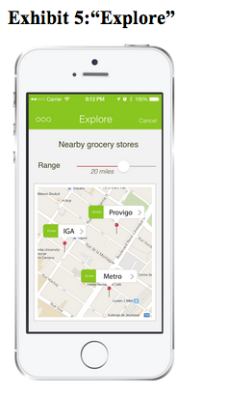

This section displays a map of grocery stores within a certain range around the user.

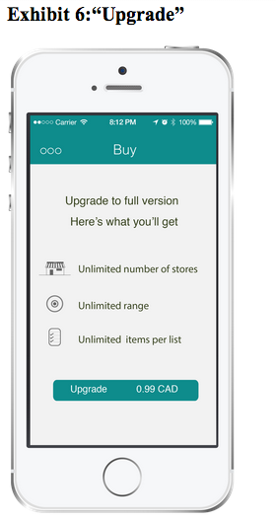**Exhibit 6: “Upgrade”**

Users can upgrade their app to the premium version. This upgrade will allow them to compare prices between an unlimited number of grocery stores (whereas in in the regular version only three can be compared at any one time), and also within an unlimited range as determined by the reach and number of participating stores. The number of items per list would also be up to the user’s discretion, whereas the system caps the list at 40 items in the regular version.

**Exhibit 7: Survey Results**

Total responses: 200

1. Do you always make a list before your grocery (**Yes**: 73%, **No**: 27%)
2. If yes, do you currently make it on smartphone or on paper? (**Paper**: 67%, **Smartphone**: 23%)
3. Approximately how many items on average do you buy in one trip?  (**less than 10**: 6%, **10-20**:13%, **20-30**: 45%, **30-40**: 16.5%, **40-50**: 8%, **More than 50**: 3%, **Don’t know**: 8.5%)
4. How often do you do your grocery? (**Every week:** 18.5 %, **Once every two weeks**: 51%, **Once every month**: 23 %, **No fixed schedule**: 7.5%)
5. Do you shop alone? Or with someone? (**Alone:** 31 %, **With someone**. 58%, **Varies every time:**11 %)
6. Do you always go to the same store? Are you willing to change the place for better price/quality deals? (**Same store no matter what**: 33 %, **Willing to change for better deals**. 67%)
7. What is the maximum amount of money that you’re generally willing to pay to upgrade an app to a premium version? (**0 CAD**: 8%, **0.99 CAD**: 68%, **1.99 CAD:** 18.5%, **2.99CAD:** 5%, **No limit:** 0.5%)